Functional Requirements Document
Template

TITLE: Explore The World
Team name: Team Explore The World
Team members: Mohamed Bashir, Karlee Fidek, Rishabh Prasad
GitHub URL: https://github.com/karleefidek/ENSE-374-Project.git

Version | Description of Change | Author | Date
1 | Section 1 | Team Explore The World | October 2, 2019
2 | Section 1, 2, 3.6, 4.1, 4.3, 4.4.1 | Team Explore The World | October 22,  2019
3 | Section 3, 4 | Team Explore The World | November 13, 2019

CONTENTS
1 INTRODUCTION 4
1.1 Purpose 4
1.2 Scope 4
1.3 Background 4
1.4 Assumptions and Constraints 4
2 METHODOLOGY 5
3 FUNCTIONAL REQUIREMENTS 5
3.1 Context and User Requirements 5
3.2 Data Flow Diagrams 6
3.3 Functional Requirements 6
4 OTHER REQUIREMENTS 6
4.1 Interface Requirements 6
4.2 Hardware/Software Requirements 7
4.3 Operational Requirements 7

INTRODUCTION
The application we are hoping to create will take input from the users about their budget, the season of travel, and their interests and recommend a travel location for the user. The recommendation will include activities and information about the cultures present at the location.

Purpose
The purpose of the application is to allow users to choose a meaningful travel location based on their indicated preferences. It should be used to help users identify interesting and purposeful activities to participate in while travelling and where to travel to.

Scope
While the general application will work for users all around the world, the animations will use Regina, Saskatchewan as an initial starting position. Therefore, the application animations would not be realistic for users not in Regina. However, the functionality will work for users in various parts of the world. We hope to continually progress the application to accept more preferences and to recommend more locations to provide a more personalized recommendation to each user.

Background
We, as students, have a limited amount of time that we are able to spend travelling. Therefore, we feel the need to make the most of that time by choosing a prime location that will meet or exceed all of our expectations. We would like to create an application that helps us choose that prime location.

Assumptions and Constraints

Assumptions
We assumed that there is no application like this that will create copyright issues. We have assumed that the use of HTML, CSS, and PHP will allow us to produce our envisioned functionality for the project. We have assumed that we can use one of our computer science student domains as a host for our application.

Constraints
- We have limited experience coding with HTML, CSS, and PHP as two of us are currently taking CS 215 and learning the languages for the first time
- We are limited by time in multiple ways. We have a short amount of time to complete the full project. We also have limited time to meet due to busy schedules.
- We have never designed or created a model-view controller before
- The application will only provide a specific number of predefined options for each preference question (select hobbies, select budgets, etc.)
- The application will have a specific number of travel locations that will be used as we cannot include every location in the world

METHODOLOGY
We have done an overall assessment of requirements and tasks to be completed at the beginning of the project. We plan to revisit and re-evaluate these at the beginning of each milestone. For the application, we plan to get a basic and simple version of the project functioning and progressively improve and increase its functionality.

FUNCTIONAL REQUIREMENTS

Context and User Requirements

Data Flow Diagrams
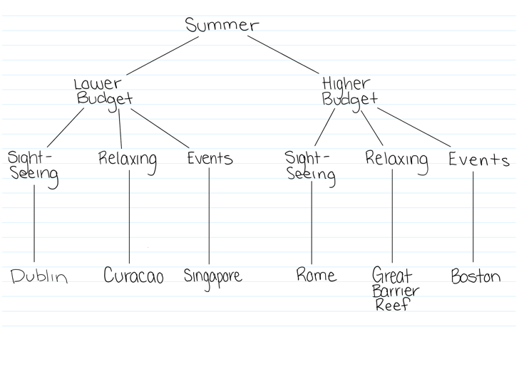
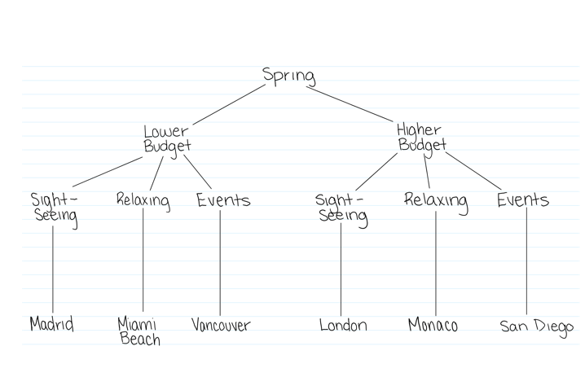
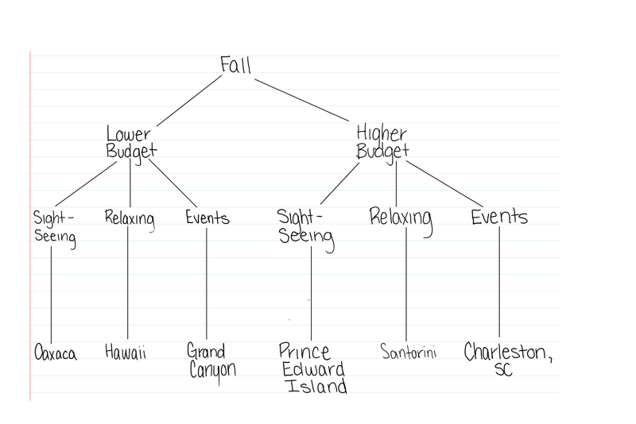
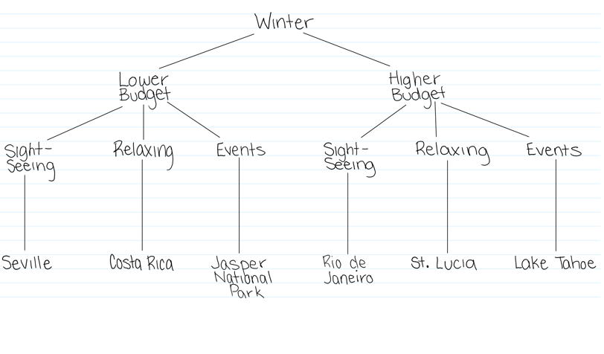

Functional Requirements
The functional requirements of this application are the ability to accept user input and the ability determine the best fitting travel location for the user. User input should be used and compared to location data to determine the location that best matches the user’s entered preferences.

OTHER REQUIREMENTS

Interface Requirements
- Initial start page – Basic, simple page that allows the user to choose to start the process of entering their preferences in order to reveal a travel recommendation.
- Question and preference input pages - Pages with simple input features that allow users to enter their travel preferences.
- Loading screen / animation page – Page that shows a plane animation from Regina to the recommended location
- Location recommendation page – Simple page that shows recommended location and suggested activities for user to participate in while travelling.

Hardware/Software Requirements
The software requirements for this application on the design side will be access to HTML, CSS and PHP. The only software requirement for user will be access to a web browser.

Operational Requirements

Security and Privacy
- Loss or corruption of data – A loss of data would mean that our application would not function properly as our application relies on the comparison of input to stored data.
- Disclosure of privileged/privacy information about individuals - The application will not store any sensitive information about the users and therefore, this is not a concern for our application. Once the user is done with their session, all information relating to them will be destroyed

Recoverability
A. In the event that the application is unavailable to users (down) because of a system failure, there is no required time limit that the application must be restored in as the application has nothing depending on it being running. However, the time required to restore it should be able to remain at a minimum amount due to the simplicity of the code.
B. The database is not consistently changing, therefore as long as any backup can be recovered the application should be able to be restored.

System Availability
The system has no time for which it is required to be available for user use. However, we would like the application to be available to users at all times as it is supposed to be beneficial for the users.

General Performance
A. Response time for queries and updates: It is expected that all queries based on user interactions will be performed quickly and that updates to the interface based on those queries will also happen in a timely manner.
B. Expected rate of user activity: It is expected that each user will complete several transactions per use of the application.

Data Retention
The data from user’s choices must be retained for the length of the user’s session. After the user has ended their session, the data can be destroyed.

